CUSTOMER SUPPORT TICKET PRIORITY PREDICTION
AND AUTOMATED ASSIGNMENT SYSTEM USING AGENTFORCE

User Story:
The Customer Support Ticket Priority Prediction and Automated Assignment System uses Salesforce and Agentforce to analyze customer support ticket descriptions, automatically determine priority as High, Medium, or Low, and trigger backend automation for appropriate support handling. The solution uses the Support Ticket Intelligence custom object, an Auto-Launched Flow, and an Agentforce subagent named Support Ticket Priority Analysis. High-priority tickets create an urgent handling task and are assigned to a senior support agent, reducing manual effort and improving response time.

INTRODUCTION

Project Overview :
Customer support teams receive a large number of tickets daily, while prioritization and assignment can be manual. This project provides a Salesforce-based solution that analyzes ticket information, classifies urgency, assigns the appropriate support level, and initiates automation for critical cases.

Purpose :

    - Automatically classify support tickets as High, Medium, or Low priority.
    - Retrieve the latest support ticket associated with a customer Account.
    - Reduce manual prioritization and assignment effort.

    - Create an urgent handling task for High-priority tickets.
    - Use Agentforce to analyze ticket details and trigger backend automation.
    - Improve ticket response and resolution efficiency.

IDEATION PHASE

Problem Statement (Customer Problem Statement Template)

PS | I am (Customer  ) | I’m trying to | But | Because | Which makes me feel
PS-1 | Support Agent | focus on critical tickets first | tickets are not always prioritized automatically | ticket prioritizatio n can be manual | frustrated
PS-2 | Customer | get urgent issues resolved quickly | critical issues may wait behind lower-priority tickets | support teams handle large ticket volumes | concerned
PS-3 | Support Manager | assign tickets to the right support level | assignment may require manual decisions | ticket urgency is not consistently analyzed | overwhelme d
PS-4 | Support Agent | identify urgent issues from descriptions | important keywords can be missed | ticket descriptions contain different urgency signals | uncertain
PS-5 | Support Manager | reduce  SLA-related risk | older unresolved tickets may remain unnoticed | SLA risk needs additional checking | concerned

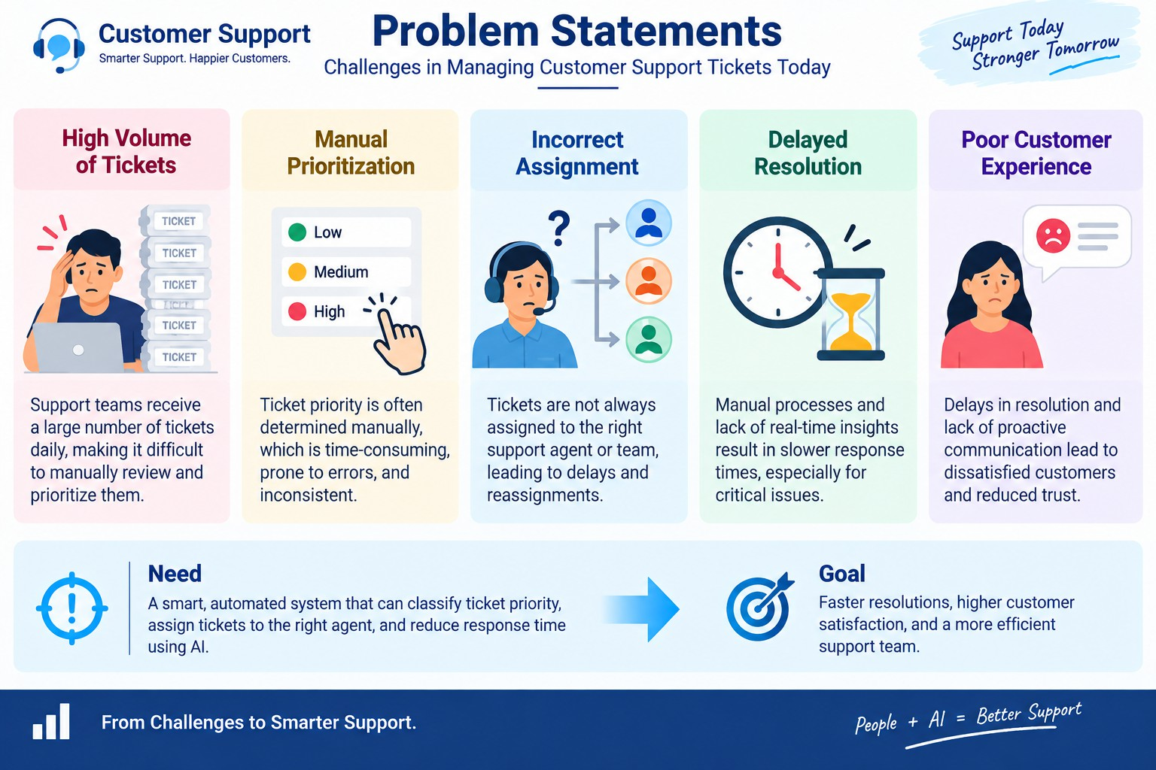

Empathy Map Canvas
User Persona: Support Agent
    - Think & Feel: Wants critical issues identified quickly so urgent customer problems receive attention.
    - Hear: Receives customer issue descriptions and support requests.
    - See: Ticket status, issue type, description, priority level, assignment, and SLA risk.
    - Say & Do: Reviews tickets, handles assigned cases, and focuses on urgent support issues.
    - Pain: Manual prioritization, missed urgency signals, and delays in handling critical tickets.
    - Gain: Automatic priority classification, clearer assignment, urgent-task creation, and reduced manual effort.

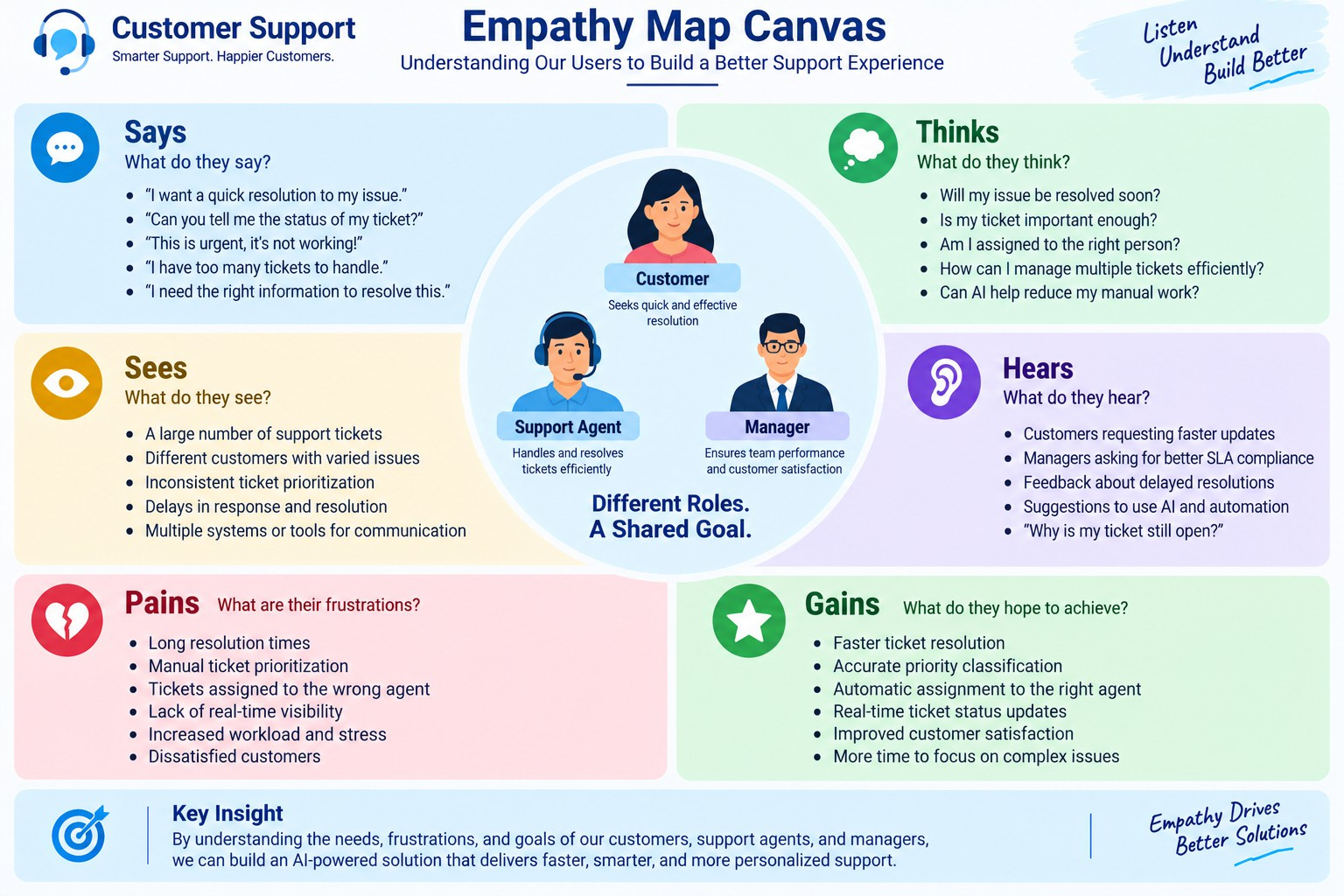

Brainstorming & Idea Prioritization

Ideas Considered
    - Manual ticket registers
    - Spreadsheet-based ticket tracking
    - Standalone support portal
    - Salesforce CRM with Agentforce

Final Selection
Salesforce CRM selected due to:
    - Automation through Salesforce Flow
    - AI-assisted ticket analysis through Agentforce
    - Automatic priority classification
    - Automatic urgent-task creation
    - Reduced manual support effort

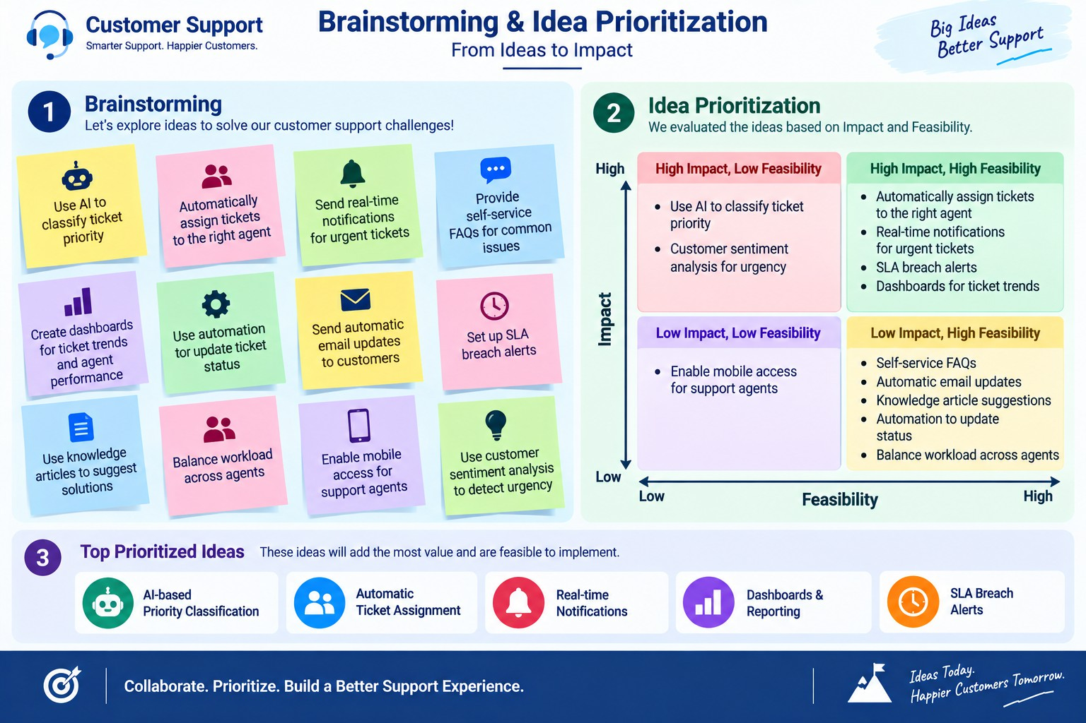

REQUIREMENT ANALYSIS PHASE

Customer Journey Map
Stages:
    - Ticket Creation → Account Identification → Ticket Retrieval → Description Analysis → Priority Classification → Agent Assignment → Urgent Task Creation → Support Handling → Resolution

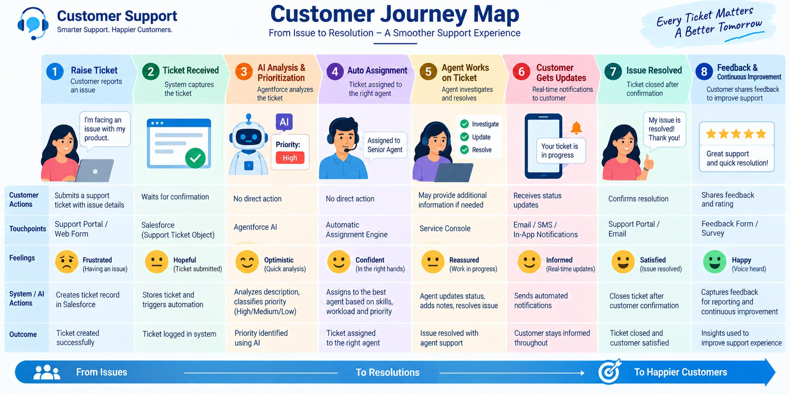

Solution Requirements

Functional Requirements

FR No | Requirement
FR-1 | Support ticket creation and management
FR-2 | Account and Contact association
FR-3 | Ticket description analysis
FR-4 | Automatic priority classification
FR-5 | High-priority task creation
FR-6 | Support agent assignment
FR-7 | SLA breach risk checking
FR-8 | Agentforce conversational analysis

Non-Functional Requirements

NFR | Description
Usability | Clear Agentforce interaction and understandable priority messages
Reliability | Consistent priority classification based on configured conditions
Performance | Quick retrieval and analysis of the latest support ticket
Security | Controlled Salesforce access to customer and ticket information
Maintainability | Flow and Agentforce configuration can be updated
Scalability | Supports increasing support-ticket volumes through Salesforce automation

Data Flow Diagram

Flow:
Customer / Support Request → Account → Latest Support Ticket → Ticket Description
→ Analyze Description → Priority Level → High/Medium/Low Decision → Agent Assignment → High-Priority Task (if applicable) → Final Response
Agentforce: User provides Account Name → Agentforce Support Ticket Priority Analysis → Auto-Launched Flow → Ticket Analysis → Priority and Assignment Output
→ Response to User.

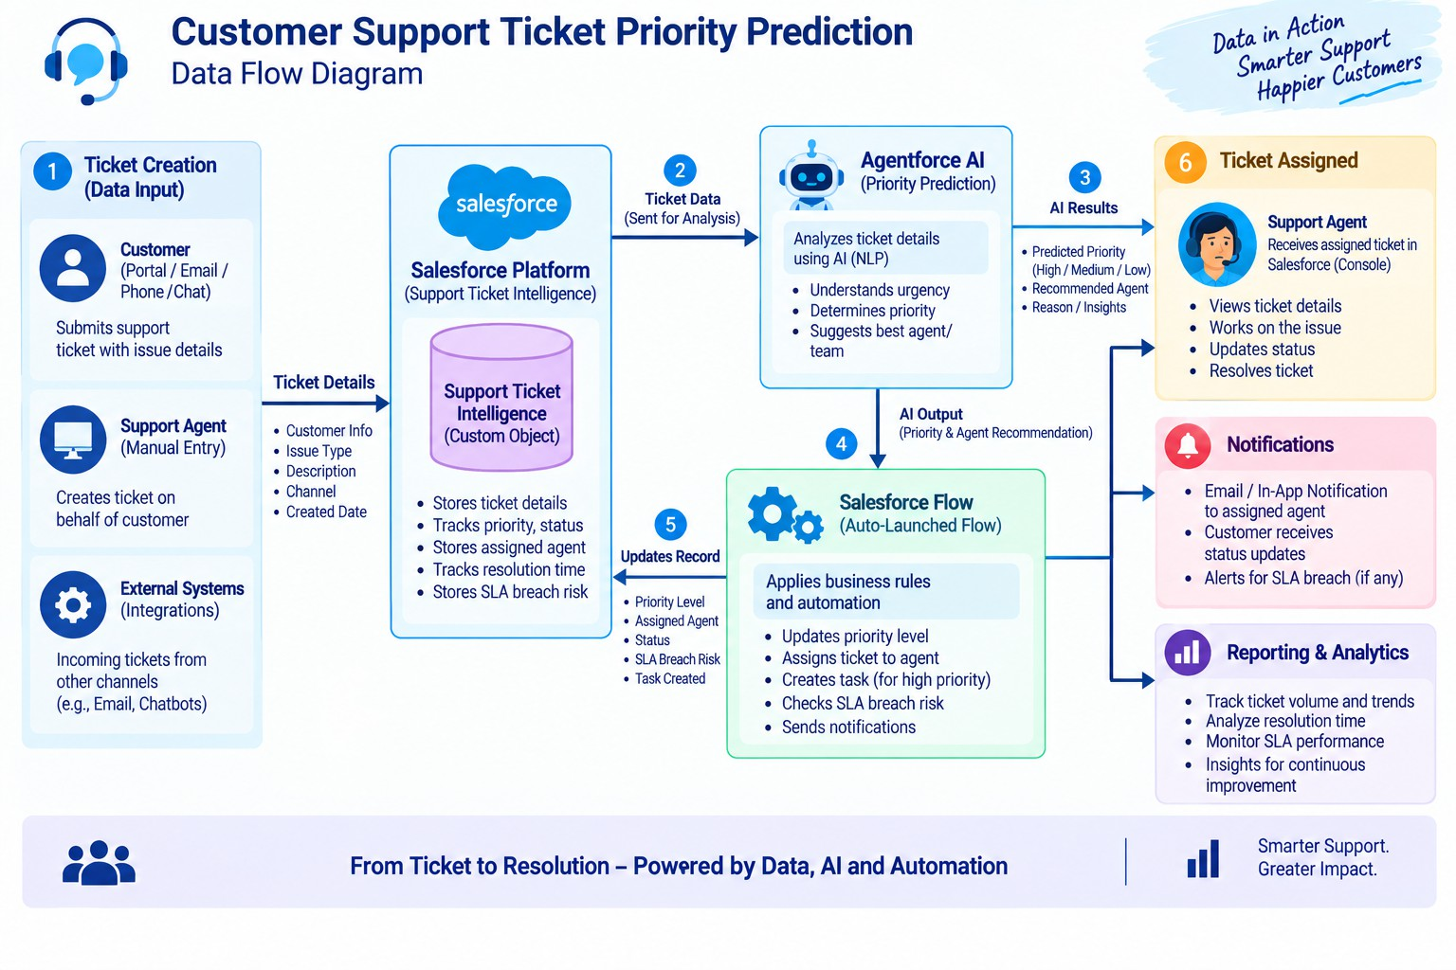

Technology Stack

Layer | Technology
Platform | Salesforce
Database | Support_Ticket_Intelligence c with Account, Contact, User and Task records
Logic | Auto-Launched Flow
AI | Agentforce
Agent Configuration | Support Ticket Priority Analysis subagent
Automation | Flow Decision, Assignment and Create Records
Output | Agentforce conversation response

PROJECT DESIGN PHASE

Problem–Solution Fit

Problem | Solution | Benefit
Manual ticket prioritization | Flow analyzes description and sets priority | Faster identification of urgent cases
Urgent issues may be missed | High-priority keyword decision | Critical cases receive attention
Manual task creation | Flow creates Task for High priority | Reduced manual effort
Manual support assignment | Flow sets assigned support level | More consistent handling
SLA risk can be overlooked | Optional SLA Risk decision | Better risk awareness
Need for conversational access | Agentforce subagent | AI-assisted interaction

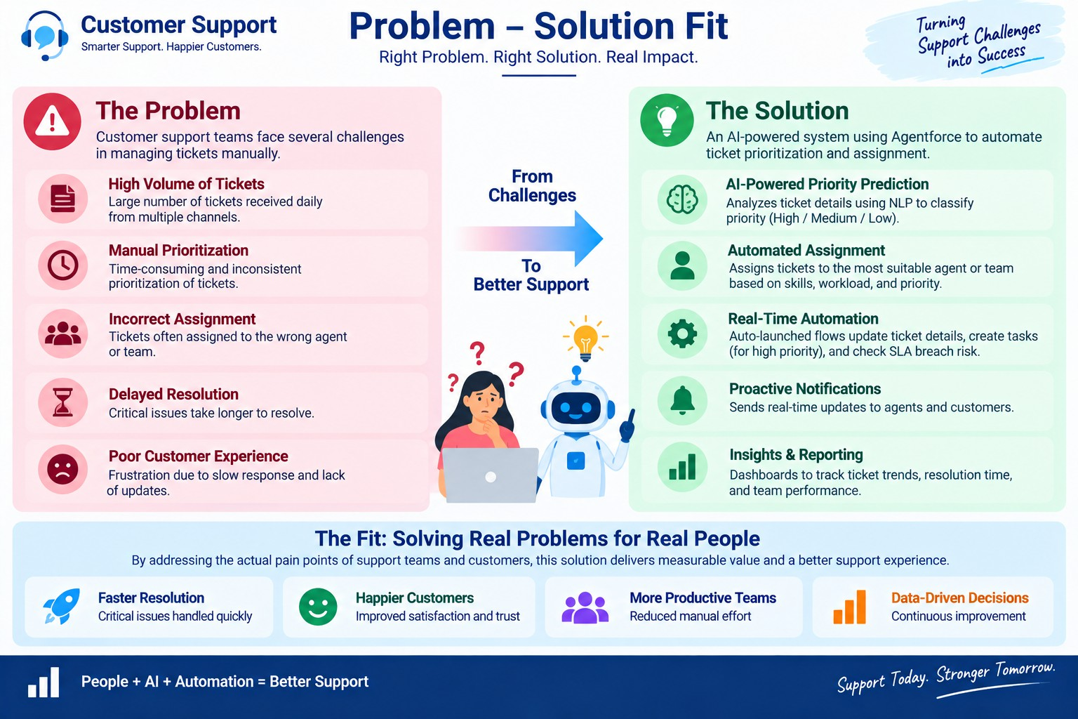

Proposed Solution

Functional Requirements

Parameter | Description
Problem | Manual ticket prioritization and assignment causing delays in handling critical customer support issues
Solution | Salesforce-based Customer Support Ticket Priority Prediction and Automated Assignment System
Innovation | Agentforce AI + Auto-Launched Flow for analyzing ticket descriptions, automatically classifying priority,

 | assigning support level, and triggering urgent-task automation
Impact | Faster identification of critical tickets, reduced manual effort, improved response time, and better support-team productivity
Business Model | Customer support operations involving customers, support agents, support managers, and AI-assisted ticket handling
Scalability | Supports increasing support-ticket volumes through Salesforce automation, with scope for additional assignment rules, SLA monitoring, and priority indicators

Solution Architecture
Components:
Users / Support Team → Agentforce → Support Ticket Priority Analysis → Auto-Launched Flow → Account & Ticket Data → Description Analysis → Priority Decision → Task / Assignment → Final Message → Agentforce Response

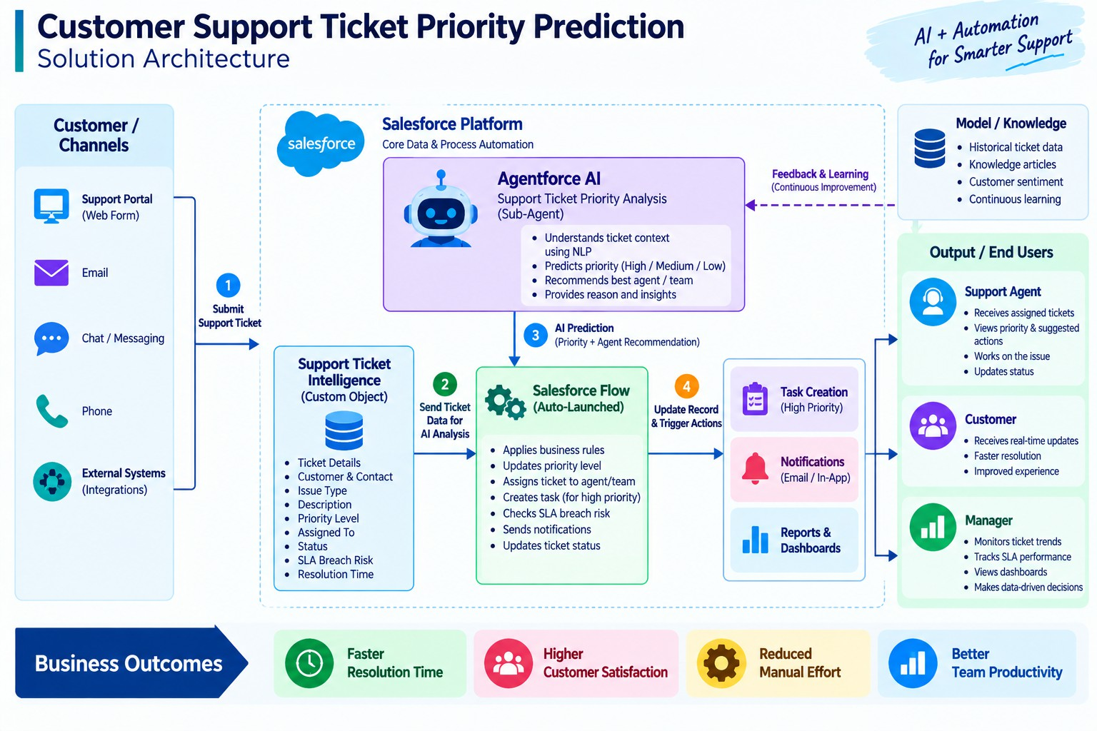

PROJECT PLANNING & SCHEDULING

Project Planning
    - Agile methodology
    - Epics → Stories → Story Points
    - Sprint-based execution
    - Velocity calculation used for estimation
Product Backlog, Sprint Schedule, and Estimation (4 Marks)
Use the below template to create product backlog and sprint schedule

Sprint | Functional Requirement (Epic) | User Story Number | User Story / Task | Story Points | Priority | Team Member s
Sprint-1 | Developer Setup | USN-1 | As a system administrator, I want to configure the Salesforce environment for Support Ticket Intelligence so that the support | 3 | High | Member1

Sprint | Functional Requirement  (Epic) | User Story  Number | User Story / Task | Story Points | Priority | Team Member  s
 |  |  | automation solution can be developed.
Sprint-2 | Data Modeling | USN-2 | As an admin, I want to create the Support Ticket Intelligence object with required fields and relationships so that customer support ticket information is stored  systematically. | 5 | High | Member2
Sprint-2 | Data Modeling | USN-3 | As a support user, I want support tickets to be associated with Accounts and Contacts so that the latest customer ticket can be identified for analysis. | 3 | High | Member3
Sprint-3 | Automation | USN-4 | As a support agent, I want an  Auto-Launched Flow to retrieve the latest ticket and analyze its description so that ticket priority can be determined automatically. | 5 | High | Member4
Sprint-3 | Automation | USN-5 | As a support agent, I want tickets to be automatically classified as High, Medium, or Low based on configured urgency conditions so that critical issues receive attention  first. | 5 | High | Member4
Sprint-4 | Agentforce & Automation | USN-6 | As an AI Agent (Agentforce), I want to analyze support ticket details and trigger the backend Flow so that manual ticket prioritization is reduced. | 8 | High | Member1
Sprint-4 | Task & Assignment | USN-7 | As a support manager, I want  High-priority tickets to automatically create an urgent handling task and assign the appropriate support level so that critical tickets are handled quickly. | 5 | High | Member2
Sprint-5 | SLA  Management | USN-8 | As a support manager, I want the system to check SLA breach risk for older unresolved tickets so that potential SLA issues can be  identified. | 5 | Medium | Member3
Sprint-6 | Agentforce & Conversational Support | USN-9 | As a support user, I want to provide an Account Name to Agentforce and receive the ticket ID, priority, assigned agent, and action message so that I can understand the ticket handling outcome conversationally. | 5 | Medium | Member4

Project Tracker, Velocity & Burndown Chart: (4 Marks)

Sprint | Total Story Points | Duratio n | Sprint Start Date | Sprint End Date (Planned) | Story Points Completed (as on Planned End Date) | Sprint Release Date (Actual)
Sprint-1 | 20 | 6 Days | 24 Oct 2022 | 29 Oct 2022 | 20 | 29 Oct 2022
Sprint-2 | 20 | 6 Days | 31 Oct 2022 | 05 Nov 2022
Sprint-3 | 20 | 6 Days | 07 Nov 2022 | 12 Nov 2022
Sprint-4 | 20 | 6 Days | 14 Nov 2022 | 19 Nov 2022

Project Development Phase:

What you'll learn

- Data Modelling
- Fields and Relationships
- Lightning App Builder
- Record Triggered Flows
- Apex and Apex Triggers
- Batch Apex
- Scheduled Apex

Milestone 1: Salesforce Account

Activity 1: Creating Developer Account
Creating a developer org in salesforce.
- Go to https://developer.salesforce.com/signup

- On the sign up form, enter the following details :
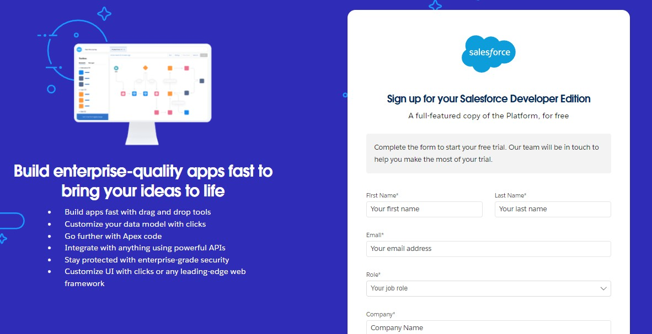
  - First name & Last name
  - Email
  - Role : Developer
  - Company : College Name
  - County : India
  - Postal Code : pin code
  - Username : should be a combination of your name and company This need not be an actual email id, you can give anything in the format : username@organization.com
Click on sign me up after filling these.

Activity 2: Account Activation
- Go to the inbox of the email that you used while signing up. Click on the verify account to activate your account. The email may take 5-10mins.

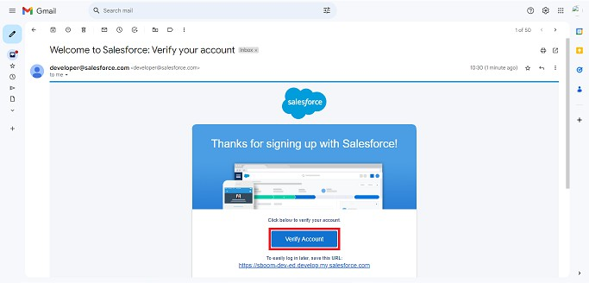
- Click on Verify Account
- Give a password and answer a security question and click on change password.
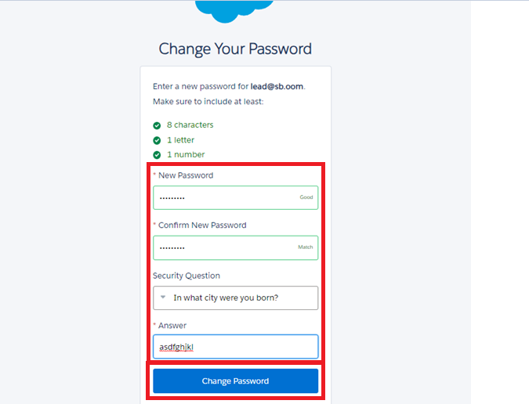
- Then you will redirect to your salesforce setup page.

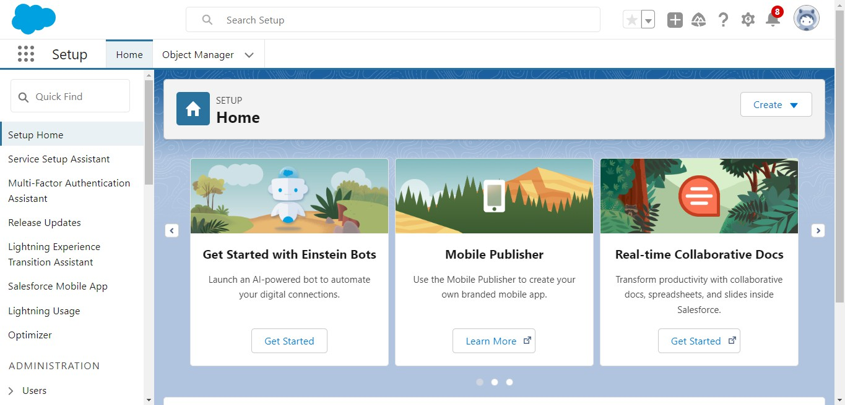

Milestone 2: Data Management-Objects

Custom Object

Object Name:
Support Ticket Intelligence

API Name:
Support_Ticket_Intelligence c

Fields

Field Label | API Name | Data Type | Description
Ticket Number | Ticket_Number c | Auto Number | TKT-{0000}
Customer | Customer c | Lookup (Account) | Related Account

Contact | Contact c | Lookup (Contact) | Customer contact
Issue Type | Issue_Type c | Picklist | Technical, Billing, General
Description | Description c | Long Text Area | Issue details
Priority Level | Priority_Level c | Picklist | Low, Medium, High
Status | Status c | Picklist | New, In Progress, Resolved
Created Date | Created_Date c | Date | Ticket date
Assigned To | Assigned_To c | Lookup (User) | Support agent
SLA Breach Risk | SLA_Breach_Risk c | Checkbox | Risk flag
Resolution Time (hrs) | Resolution_Time c | Number | Time taken

Auto-Launched Flow Logic (Modified for this Project)
- Flow Type
Auto-Launched Flow (No Trigger or called from Agentforce)

Variables

Input Variable

Label | API Name | Type | Input
Account Name | varAccountName | Text | Yes

Output Variables

Label | API Name | Type | Output
Account Id | varAccountId | Text | Yes
Ticket Id | varTicketId | Text | Yes
Priority Level | varPriorityLe vel | Text | Yes
Assigned  Agent | varAssignedTo | Text | Yes
Action  Message | varActionMess age | Text | Yes

Step-by-Step Flow Implementation

Step 1: Get Account
Element: Get Records

  - Label: Get Account
  - Object: Account
  - Condition:
    - Name Equals {!varAccountName}
  - Sort: CreatedDate DESC
  - Store: Only first record

Step 2: Assignment (Store Account Id)

Element: Assignment

  - Label: Store Account Id Set:
  - varAccountId = {!Get_Account.Id}

Step 3: Get Ticket Record
Element: Get Records

  - Label: Get Ticket
  - Object: Support_Ticket_Intelligence c
  - Condition:
    - Customer c Equals {!varAccountId}
  - Sort: CreatedDate DESC
  - Store: Only first record

Step 4: Assignment (Store Ticket Id)
Element: Assignment

  - Label: Store Ticket Id Set:
  - varTicketId = {!Get_Ticket.Id}

Step 5: Decision (Analyze Description)
Element: Decision

  - Label: Analyze Description

Outcomes:
High Priority

  - Description contains:
    - "urgent"
    - "not working"
    - "failure"

(Use multiple conditions with CONTAINS)

Medium Priority

  - Description contains:
    - "issue"
    - "slow"
    - "delay"

Default Outcome

  - Low Priority

Step 6: Assignment (Set Priority Level)
High Path

  - varPriorityLevel = "High"

Medium Path

  - varPriorityLevel = "Medium"

Low Path

  - varPriorityLevel = "Low"

Step 7: Decision (High Priority Check)
Element: Decision

  - Label: Is High Priority Condition:
  - varPriorityLevel Equals "High"

Step 8: Create Task (Only High Priority)
Element: Create Records

  - Object: Task

Set Fields:

  - Subject = "Urgent Ticket Handling"
  - WhatId = {!varTicketId}
  - Priority = High
  - Status = Not Started

Step 9: Assignment (Assign Agent Name)
Element: Assignment

  - Label: Set Assigned Agent

Set:

  - varAssignedTo = "Senior Support Agent"

Step 10: Optional SLA Check
Decision: SLA Risk Condition example:
  - If Created Date older than 2 days Then:
  - (Optional internal flag or message)

Step 11: Final Output Message
Element: Assignment

  - Label: Set Final Message Set varActionMessage:
  - High:
"High priority ticket detected. Assigned to senior agent."
  - Medium:
"Ticket marked as medium priority. Will be handled shortly."
  - Low:
"Tickets are low priority and queued for processing."

Step 12 : Save Flow
Label Name : Support_Ticket_Intellegence

Active Flow

Final Flow Structure
Start
→ Get Account
→ Assignment (Account Id)
→ Get Ticket
→ Assignment (Ticket Id)
→ Decision (Analyze Description)
→ Assignment (Priority Level)
→ Decision (High Priority)
→ Create Task
→ Assignment (Assigned Agent)
→ Optional SLA Decision
→ Assignment (Final Message)
→ End

Flow OutPut :

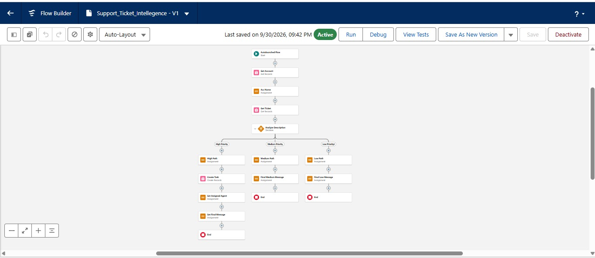

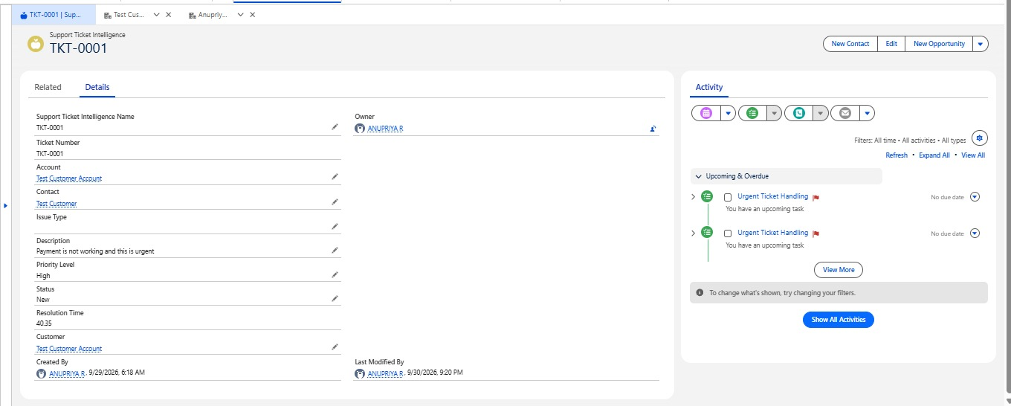

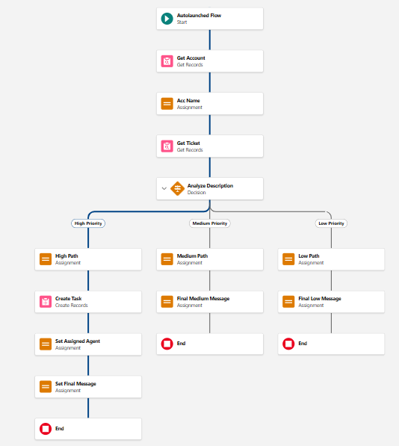
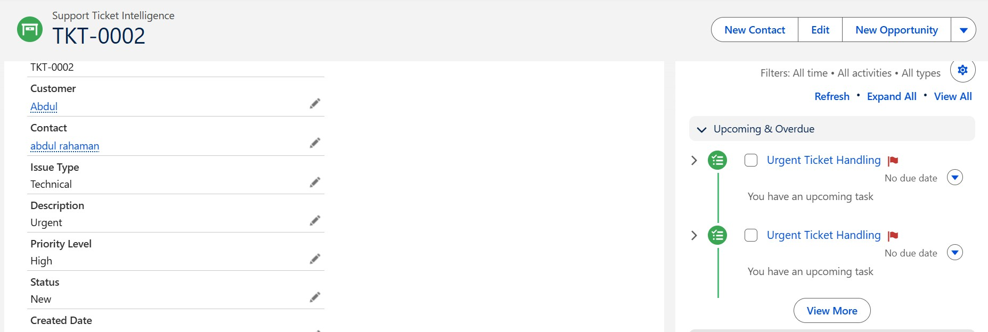

Final Outcome
  - Takes Account Name as input
  - Fetches latest support ticket
  - Analyzes description using keywords
  - Sets priority automatically
  - Creates task for urgent cases
  - Returns output to Agentforce

Agentforce Configuration
Steps :
- Go to Gear icon and Click Salesforce Go
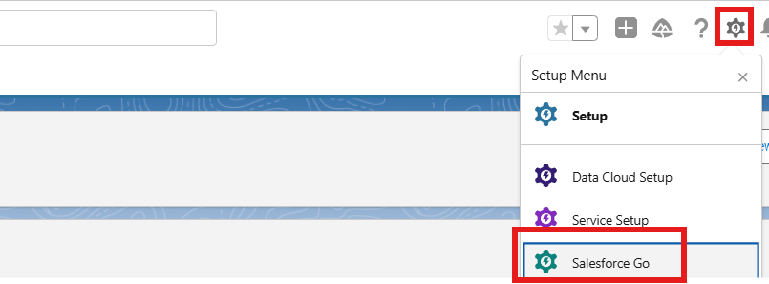
- Search Default and Select Agentforce Default then Enabled It
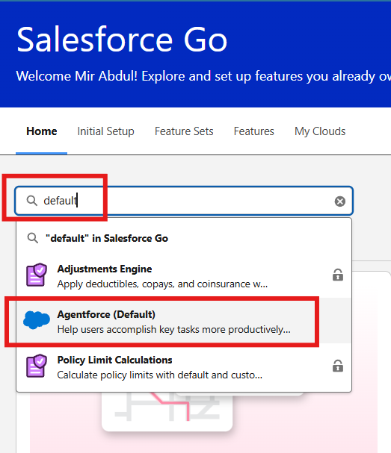
- Select Get Started ⇒ Turn On ⇒ Confirm

- Search Agents in Quick Find Box and Enabled The Agent then you will see Default Agent

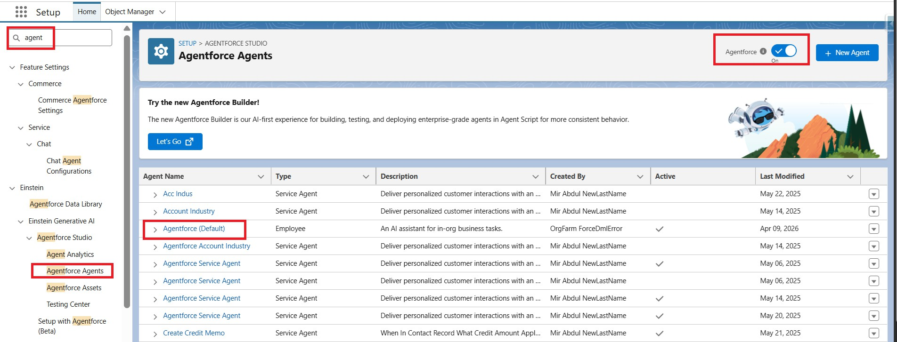
- Select Default Agent and Click Open in Builder
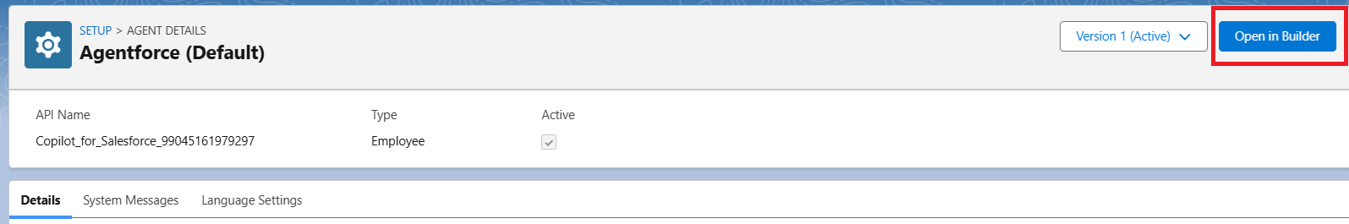

- Click New to Create New SubAgent
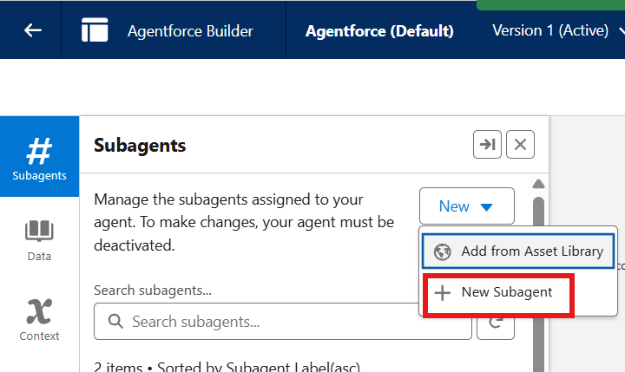

- Click Next

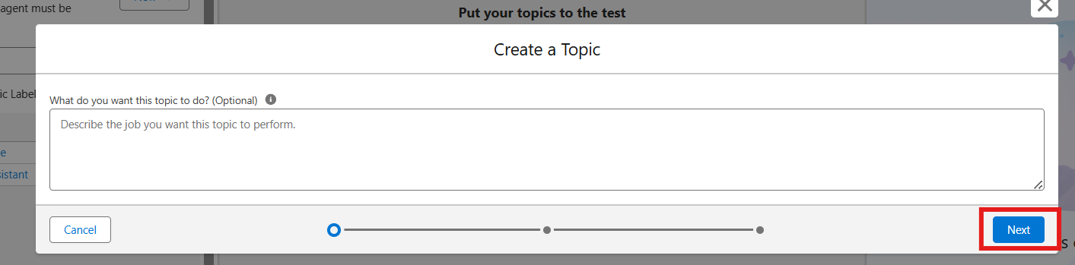

Agentforce Subagent Configuration

Name
Support Ticket Priority Analysis

API Name
Support_Ticket_Priority_Analysis

Classification Description
This topic analyzes customer support tickets to determine priority based on issue description and urgency. It handles user requests related to ticket status, issue severity, and support prioritization.

Scope
Your job is only to analyze support ticket descriptions, determine the priority level (High, Medium, Low), and trigger backend automation for task assignment. Do not handle unrelated requests such as billing, subscription management, or account updates.

Instructions
Follow these steps when this topic is triggered:

- Ask the user to provide the Account Name if not already given.
- Retrieve the latest support ticket associated with the Account.
- Read and analyze the ticket description.
- Determine priority based on keywords:
  - High Priority: contains "urgent", "not working", "failure"
  - Medium Priority: contains "issue", "slow", "delay"
  - Low Priority: if none of the above
- Set the priority level accordingly.
- If the ticket is High Priority:
  - Trigger the Auto-Launched Flow
  - Ensure a task is created for immediate handling
- Assign the ticket to the appropriate support level (e.g., senior agent for high priority).
- Return a clear response message to the user:
  - High → Inform urgent handling is initiated
  - Medium → Inform issue will be handled shortly
  - Low → Inform ticket is queued
- Do not update records directly or send emails. Use Flow for all actions.
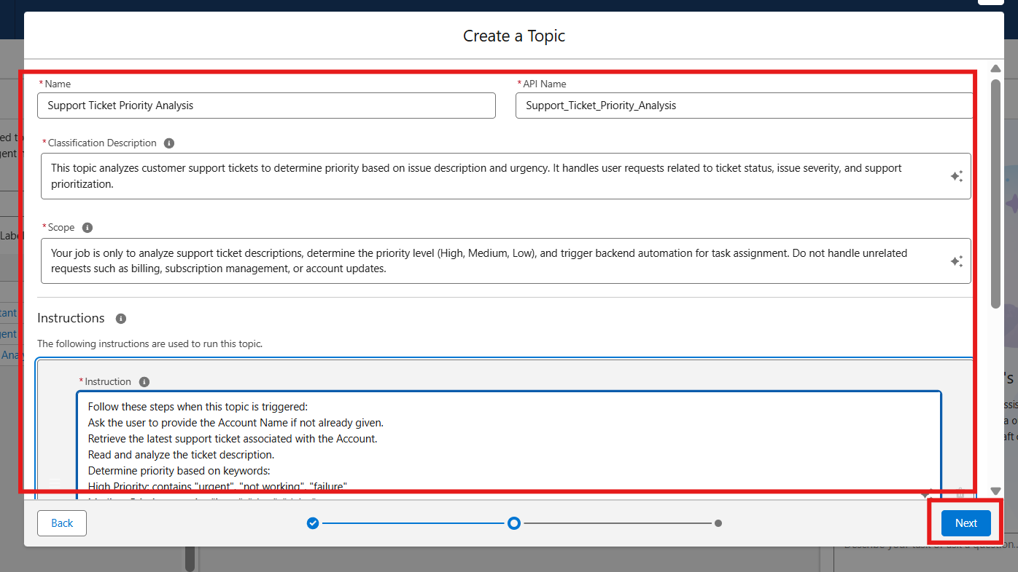

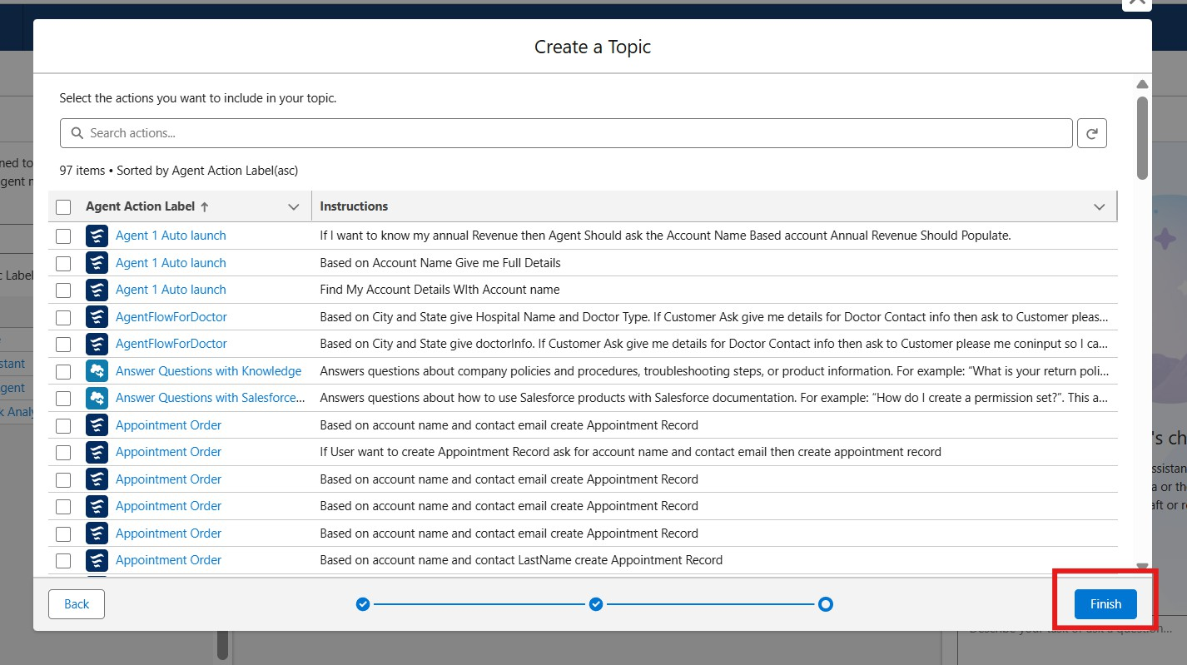

Select Topic

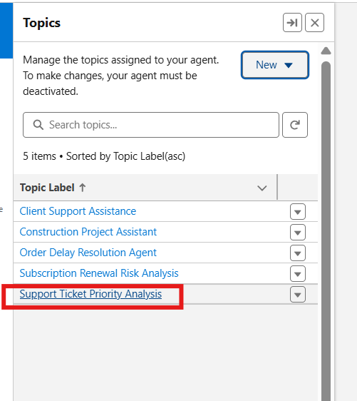

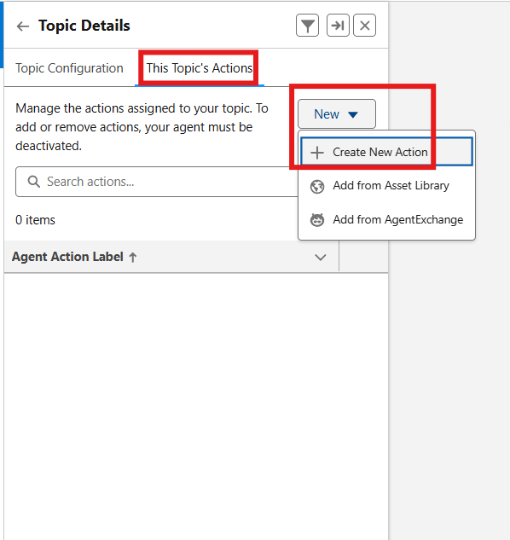

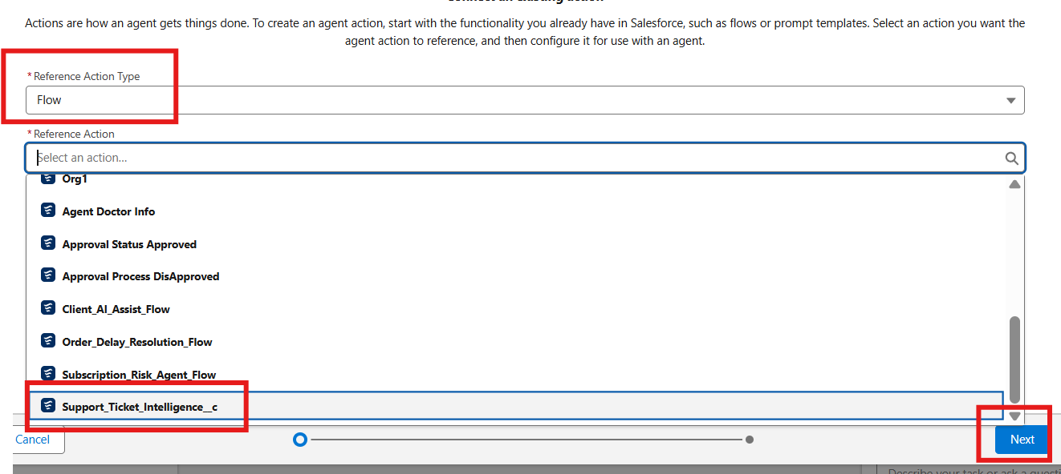

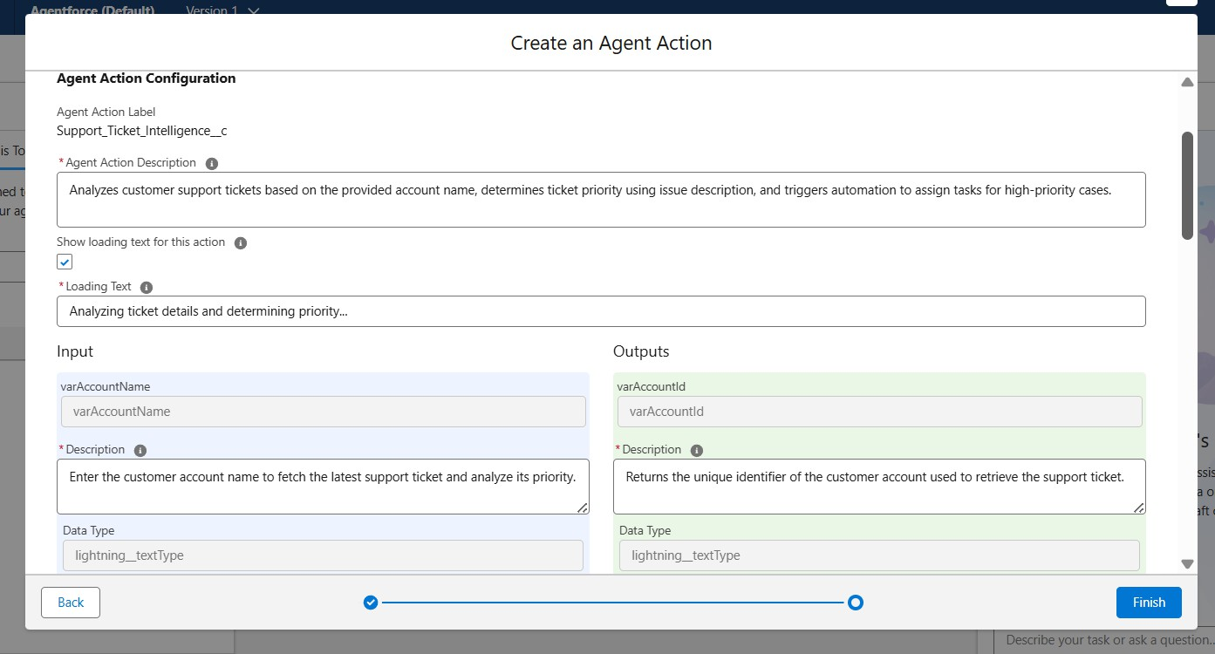

Agent Action Description
Analyzes customer support tickets based on the provided account name, determines ticket priority using issue description, and triggers automation to assign tasks for high-priority cases.

Loading Text
Analyzing ticket details and determining priority...

Input

varAccountName
- Description
Enter the customer account name to fetch the latest support ticket and analyze its priority.
- Data Type
lightning textType
- Require Input
Enabled
- Collect Data From User
Enabled

Outputs

varAccountId
- Description
Returns the unique identifier of the customer account used to retrieve the support ticket.
- Data Type
lightning textType
- Show in Conversation
Enabled
- Output Rendering
Text

varActionMessage

- Description
Displays the final message indicating ticket priority and actions taken by the system.
- Data Type
lightning textType
- Show in Conversation
Enabled
- Output Rendering
Text

varAssignedTo
- Description
Indicates the support agent or team assigned to handle the ticket.
- Data Type
lightning textType
- Show in Conversation
Enabled
- Output Rendering
Text

varPriorityLevel
- Description
Represents the calculated ticket priority level (High, Medium, Low) based on issue description.
- Data Type
lightning textType
- Show in Conversation
Enabled
- Output Rendering
Text

varTicketId
- Description
Returns the unique identifier of the support ticket analyzed by the system.
- Data Type
lightning textType
- Show in Conversation
Enabled
- Output Rendering
Text

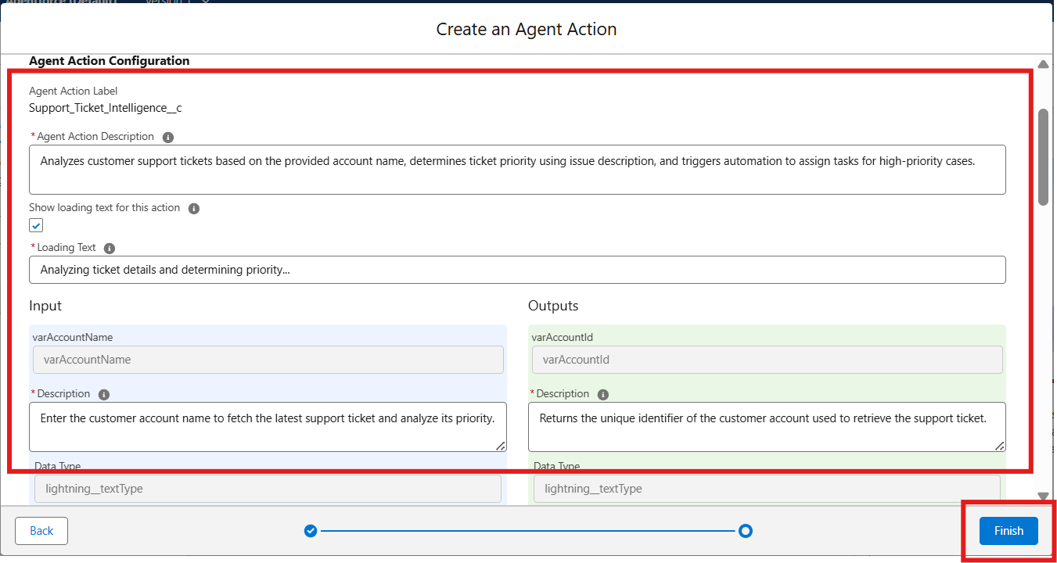

Final OutPut :

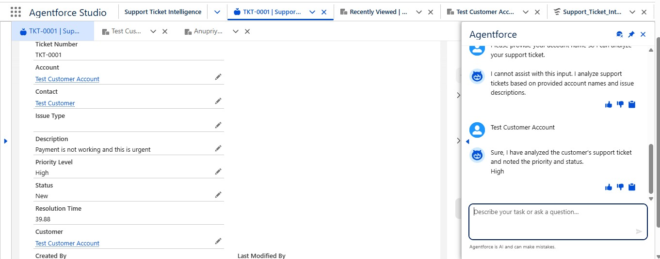

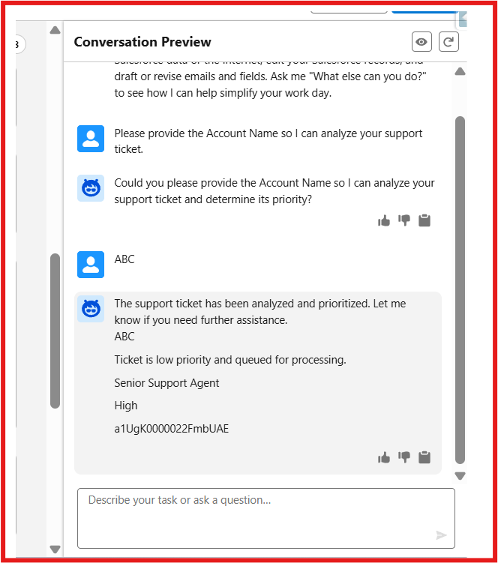

Note: If you would like to extend this scenario, you can add more variables to the flow and configure them in the agent. This will help you achieve better outputs. It’s a great way to learn. If you'd like to explore more scenarios, feel free to get in touch with me.

FUNCTIONAL & PERFORMANCE TESTING

During testing, screenshots were captured from Salesforce to validate vehicle creation, dealer assignment, stock validation triggers, order status updates, batch processing, scheduled reminders, and dashboard analytics. All features were verified to ensure correct functionality and performance.

ADVANTAGES & DISADVANTAGES

Advantages

  - Automatic Ticket Prioritization – Classifies support tickets as High, Medium, or Low based on ticket description.
  - Faster Identification of Critical Issues – Helps support agents focus on urgent tickets first.
  - Reduced Manual Effort – Automates ticket analysis, priority setting, task creation, and assignment.
  - Intelligent Ticket Handling – Agentforce analyzes ticket details and initiates the appropriate backend automation.
  - Automatic Urgent Task Creation – High-priority tickets automatically create an Urgent Ticket Handling task.
  - Improved Support Assignment – Assigns High-priority tickets to the appropriate support level, including a senior support agent.
  - Conversational Support – Support users can interact with Agentforce to analyze ticket information and receive the outcome.
  - Better Response Time – Automation helps reduce delays in handling critical customer issues.
  - SLA Risk Awareness – The solution can check older unresolved tickets for potential SLA breach risk.
  - Scalable Support Operations – Salesforce automation can support increasing volumes of support tickets.

  - Improved Team Productivity – Reduces repetitive work and allows support teams to concentrate on ticket resolution.

Disadvantages

  - Keyword-Based Priority Logic – The documented priority classification depends on configured keywords such as urgent, not working, failure, issue, slow, and delay.
  - Limited Understanding of Context – The current implementation may not capture every possible urgency signal because the documented logic is based on configured conditions.
  - Dependence on Accurate Ticket Data – Correct Account, Contact, and ticket information is required for successful analysis.
  - Flow Configuration Dependency – Changes to ticket handling require maintenance of the Auto-Launched Flow and its logic.
  - Agentforce Configuration Dependency – Agentforce responses and actions depend on properly configured subagent instructions and Flow actions.
  - Limited Scope of Agentforce – The documented Agentforce subagent is focused on ticket analysis, priority determination, and backend automation; unrelated requests such as billing or subscription management are outside its scope.
  - SLA Monitoring is Limited – The current implementation includes an optional SLA-risk check rather than a comprehensive SLA monitoring and escalation solution.
  - Assignment Logic May Need Expansion – Additional support teams or more sophisticated assignment rules would require further configuration.
  - Maintenance Required – Priority keywords, Flow variables, Agentforce outputs, and assignment logic may need to be updated as support requirements evolve.
  - Limited Analytics in Current Scope – Advanced analytics for priority trends and resolution performance are identified as future scope rather than part of the current implementation.

Conclusion:

The Customer Support Ticket Priority Prediction and Automated Assignment System demonstrates how Salesforce Flow and Agentforce can work together to reduce manual support-ticket handling. The solution retrieves the latest ticket for an Account, analyzes its description, classifies priority, creates an urgent task for High-priority cases, assigns a support level, and returns a clear conversational response. This supports faster ticket handling, reduced manual effort, intelligent prioritization, and better team productivity.

FUTURE SCOPE
  - Add more priority indicators and business rules.
  - Extend Agentforce outputs with additional ticket information.
  - Add more sophisticated SLA monitoring and escalation.
  - Support additional support teams or assignment rules.
  - Introduce analytics for priority trends and resolution performance.
  - Add more variables and configure them in the Agentforce action for richer outputs.

APPENDIX
  - A. Custom Object: Support Ticket Intelligence
  - B. Key Salesforce Records: Account, Contact, User, Task
  - C. Flow: Support_Ticket_Intellegence – Auto-Launched Flow
  - D. Agentforce Subagent: Support Ticket Priority Analysis
  - E. Agentforce Action: Flow-based Support Ticket Intelligence action

Thank You

